**ASSIGNMENT-24.3:**

A table named employee is created and the data is loaded from the local file system. The contents of the table is displayed as below.

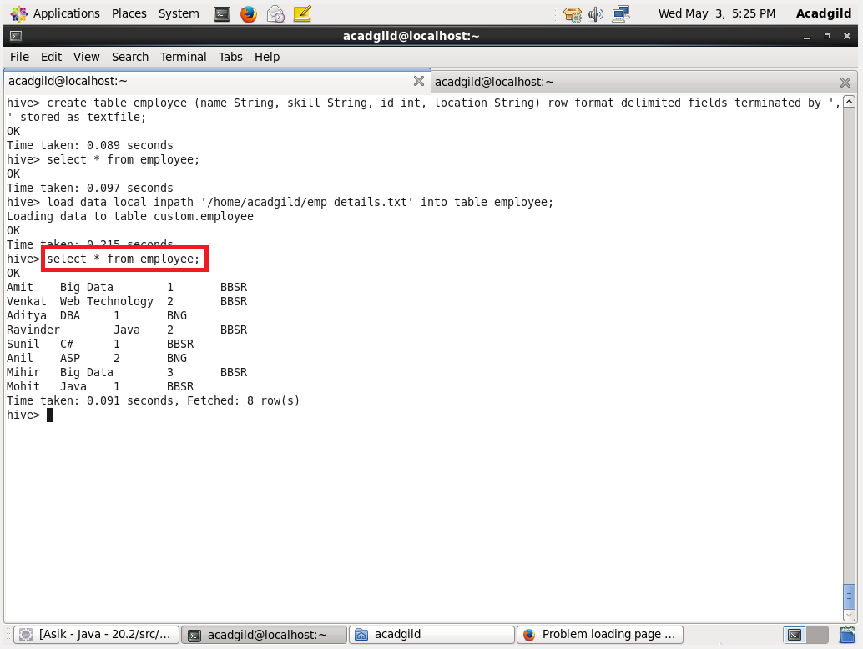

**QUESTION :** Calculate the number of employees corresponding to each skill from the table 'employee' which is loaded in the Demo.

